Task 1

MudasirAli_Task1-Qt and Qt creator

Outlines :

• What is Qt ?
• What is Qt Creator?
• Applications of Qt and Qt Creator
• How to install Qt ?
• How to install Qt creator?
( Using terminal )

• What is Qt ?
Qt (pronounced "cute") is a widget toolkit for creating graphical user interfaces as well as cross-platform applications that run on various software and hardware platforms such as Linux, Windows, Android and macOs . Many large applications use QT, such as the Plasma desktop environment and its applications. But also, applications known as VLC use it.

• What is Qt Creator ?
There is no better way to take advantage of QT than by using QTCreator. QTCreator is a lightweight, open-source framework that integrates seamlessly with many QT developer needs. It is also designed to make C++ ,Python and also other languages development of the Qt application faster and easier.

• Applications of Qt and Qt Creator

- Version Control
- Integrated UI Design
- Project and Build Management
- Multiple Targets
- Qt Device Emulator
- Qt Quick Compiler

How to install Qt

- Search the Terminal in your window box
- Open the Terminal

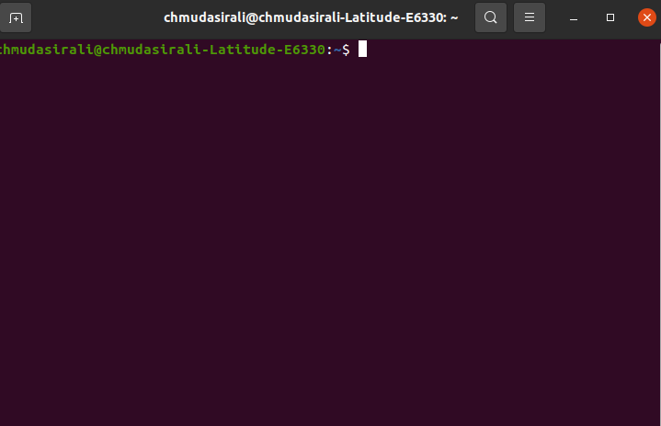
- Write the command on Terminal sudo apt install qt5-default
- Then enter the password that you have organized already for Ubuntu 20.04 LTS
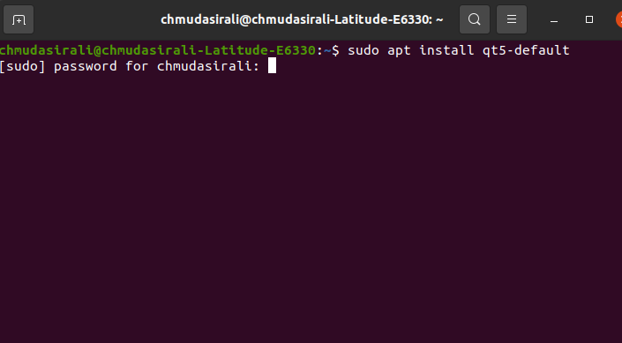
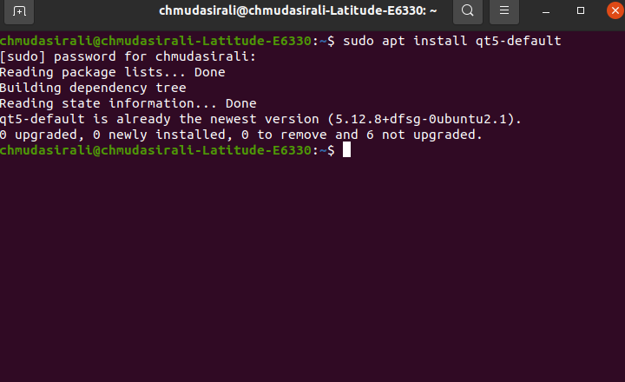
- Qt is now installed . ( Here Qt is already installed in my operating system that why its done . )

How to install Qt Creator

- Now Qt is installed and now we installed Qt Creator
- Write command in the Terminal sudo apt install qtcreator
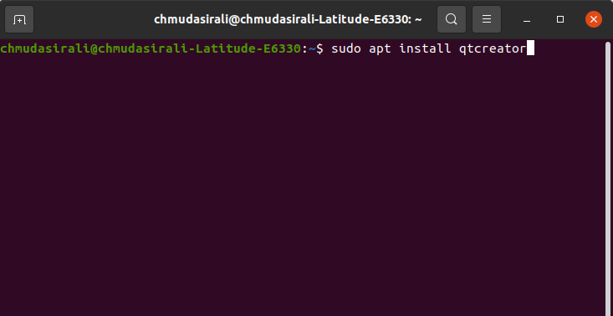

- Now provide your password that you have already organized for your Ubuntu same like Qt installation .
- The Qt Creator will start installing
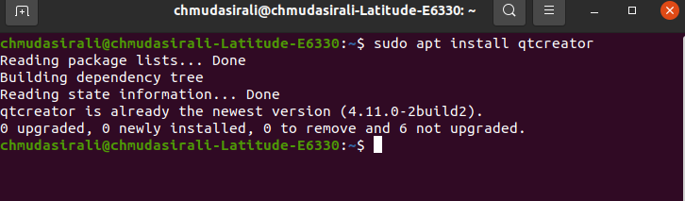
- Now Qt creator is Installed now ( It is already installed in my operating system that’s why it shows done )

- Now after installation , go to the window box
- Search here Qt Creator
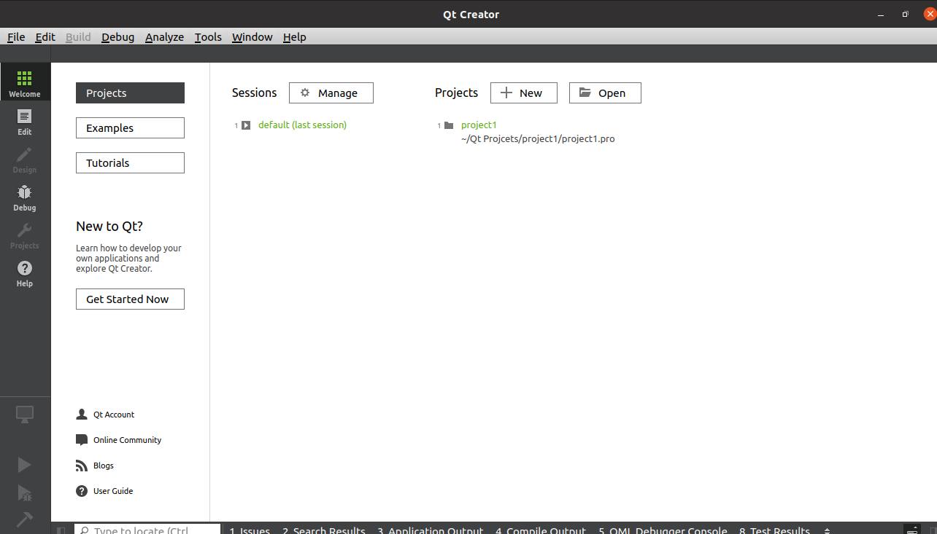
- There you find it and use it .

